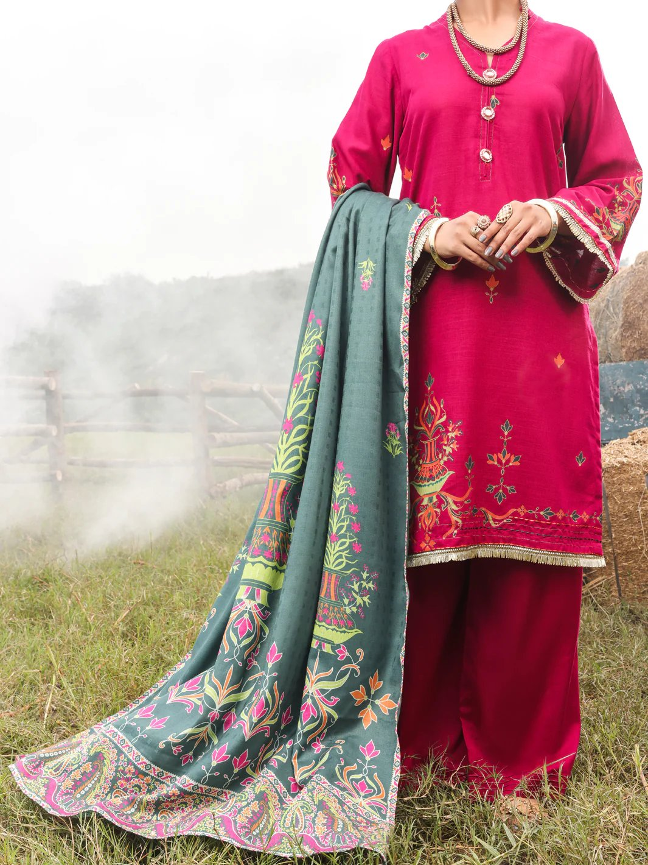

# PINK CAMBRIC 3 PIECE STITCHED - AWP-3PS-576

priceRs.8,437.50

ADDITIONAL INFO

|  |  |
| --- | --- |
| **Color** | Light Pink |
| **Pieces** | 3 Pieces |
| **Fit Type** | — |
| **Fabric** | Cambric, |
| **Season** | Winter Collection |
| Disclaimer | Due to the photographic lighting & different screen calibrations, the colors of the original product may slightly vary from the picture. |